“As the deer pants for the water, so longs my soul for you, O God”
Ps. 42: 1
Heather Ann Spring Kariel
Celebration of Life Memorial Service
January 23, 2021, 2:00 pm
United Church of Canada Athabasca Pastoral Charge

All Music shared through CCLI Copyright License: 11397172 Size A, Streaming License: 20473845 Size A
Words of Welcome
Leader: Peace be with you
All: And also with you.
Hymn: VU 703 “In the Bulb there is a Flower”
1 In the bulb there is a flower;
in the seed, an apple tree;
in cocoons, a hidden promise:
butterflies will soon be free!
In the cold and snow of winter
there's a spring that waits to be,
unrevealed until its season,
something God alone can see.
2 There's a song in every silence,
seeking word and melody;
there's a dawn in every darkness,
bringing hope to you and me.
From the past will come the future;
what it holds, a mystery,
unrevealed until its season,
something God alone can see.
3 In our end is our beginning;
in our time, infinity;
in our doubt there is believing;
in our life, eternity.
In our death, a resurrection;
at the last, a victory,
unrevealed until its season,
something God alone can see.
Invitation to Confession:
Leader: Gracious God, as people called to be your presence in the world, we search our hearts, and ask your forgiveness:
for opportunities not taken, for care not given,
All: forgive us, we pray.
For sorrow not shared, for joy not celebrated,
forgive us, we pray.
For love not offered, forgiveness not extended,
forgive us, we pray.
For those failings we cannot speak aloud,
forgive us, we pray.
Gracious God, we seek your healing grace,
and ask forgiveness in the name of Jesus. Amen.
Words of Assurance:
Eulogy:
Hymn: “House of God Forever” by Jon Foreman (adaptation of Psalm 23 prerecorded by Allison Ames)
First Reading: Eccl 3:1-8
Second Reading: 1 Peter 1:3-9
Sermon: If Heather was planning a sermon, she might do it like she did her cardmaking class. She would choose a focal point first, well, that’s really easy. Today our focal point is Heather, very little decision-making here. Then she would look for a color scheme to compliment that focal point. What better support of the focal point than our scriptures? They draw attention to the parts we most want to highlight. Then she would look for ornamentation to decorate and compliment the focal point, not to overwhelm it. Last, she would add words, a sentiment or phrase that would bring out the message she intended to say. The result would be a pleasing card that would appeal and communicate something special.
Our focal point, as I said, is Heather, and I could go on about the many things she did or said, and didn’t do or didn’t say, but it’s not so much what she did that we will remember, but how and why she did things. She wasn’t perfect by any means, and often depended on her team to help keep the classroom in her house organized. She wasn’t a world-famous designer or a fabulously wealthy business owner, and that’s okay.
The scriptures say there is a time and a purpose for everything under heaven, and that is certainly true of the way Heather lived her life. There was a time for dancing in flouncy big dresses as the callers sang and the fiddles played. There was a time for speaking, in Toastmasters and in her run for council. There was a time of building, when she planned a restaurant right down to how people would feel as they sat around tables. There was a time for keeping and a time for throwing away, when she moved to her dream home, and the fabulous garage sale that brought all the paper crafters to the house in search of bargains.
There was also a time to plant and to build up, with the many people she mentored, and with the passionate advocacy she gave for people with developmental delays. There was a time for peace, which was most of the time, but a time for war when she saw systems short-changing people she cared about. A time for embracing her daughters and a time for letting go as petheyople grew up and moved away or became more independent and capable because she had believed in them so well. A time for sewing dresses for young and old and a time for tearing them apart so they could be mended and remodelled.
The big surprise, for me, was how well she lived into the second scripture we heard today. The cancer was a source of much suffering for her, with several surgeries and medical procedures, the back pain that she had to endure, and the emotional stress of the cancer diagnosis decades too soon. The genuineness of her faith was tested by fire, and found to be more precious than gold!
Time for some accents. The first time I remember with Heather was almost nine years ago when we first moved to Athabasca. Heather offered to drive us around town, showing us the highlights and giving some history. You would think that a tour of this place would take only a few minutes, but not with Heather! I will never forget her showing us where the RCMP station was and telling us the big cages were for bears! Or how she told us all about the rich history of this building we are worshiping from today. Or how she roped a bunch of us not once but twice into doing a historic fashion show stretching all the way from the fur trading days into the present, with a stream of beautiful wedding gowns. She knew her stuff!
She also knew how to be generous. When she went off to a square dance convention or a scrapbooking retreat, a cruise or a library workshop with Doug, there would be little momentos tucked into her suitcase for folks back home. Remember the flower hair clips from Hawaii, Marilyn? I still have the rock with Be Still and Know she and Doug found in the States.
What sentiment do we want to finish on? That’s a tough one, and I go back to the last time I visited her on Christmas eve. We talked about our project, making stars for the first Sunday in January. It had become a tradition to give out stars with words of inspiration on them. Last year, Heather had the word ‘serenity’ on her star, and had been rather disappointed. But when June came around with the diagnosis, serenity became something she practiced with intentionality and discipline. She would recite the serenity prayer, and she watched some of her friends and acquaintances also faced cancer without serenity, and were not able to be honest with themselves and their families that they were sick and dying. She was determined to live differently, in faith and hope and truth. She was determined to care for others, and to give her husband and girls one last Christmas together. She made the stars for the church with the help of Marilyn and Doug, and died the Sunday that we were giving them out.
In the United Church, we don’t brag much about our faith, but we have it, and find the courage to face our sufferings with serenity and fortitude, wisdom and courage. Heather’s faith sustained her and will continue to inspire us, and she has received the outcome of her faith. She is singing with the angels, yes, our Heather is singing with joy, and helping God design sunsets to make sure that Melon Mango and Flirty Flamingo is added to the color scheme for a perfectly serene sky. May we find courage and inspiration and hope in her example, and may she live forever in our hearts. Amen
Prayers of Thanksgiving and Concern
O God, our strength and our redeemer, giver of life and conqueror of death,
we praise you with humble hearts.
In your presence, we remember Heather,
and we praise you for your steadfast love for her
all the days of her earthly life.
We thank you for all that she was
to those who loved her.
We thank you that for Heather
all sickness and pain are ended, and death itself is past,
With faith in your great mercy and wisdom,
we entrust Heather to your eternal care.
In the name of Jesus Christ,
Amen.
A New Creed (all)
We are not alone, we live in God's world.
We believe in God:
who has created and is creating,
who has come in Jesus, the Word made flesh,
to reconcile and make new,
who works in us and others by the Spirit.
We trust in God.
We are called to be the Church:
to celebrate God's presence,
to live with respect in Creation,
to love and serve others,
to seek justice and resist evil,
to proclaim Jesus, crucified and risen,
our judge and our hope.
In life, in death, in life beyond death,
God is with us. We are not alone. Thanks be to God.
The Lord’s Prayer
Hymn: VU 586 “We Shall Go Out With Hope of Resurrection”
1 We shall go out with hope of resurrection;
we shall go out, from strength to strength go on;
we shall go out and tell our stories boldly;
tales of a love that will not let us go.
We'll sing our songs of wrongs that can be righted;
we'll dream our dreams of hurts that can be healed;
we'll weave a cloth of all the world united
within the vision of new life in Christ.
2 We'll give a voice to those who have not spoken;
we'll find the words for those whose lips are sealed;
we'll make the tunes for those who sing no longer,
expressive love alive in every heart.
We'll share our joy with those who still are weeping,
raise hymns of strength for hearts that break in grief,
we'll leap and dance the resurrection story,
including all in circles of our love.
Commendation:
Sending Forth and Slide Show
Minister: Rev. Monica Rosborough
Music: Ida Edwards, scripture: Andrea Schwertz, Linda Dube
Eulogy: Allison Ames, Doug Kariel, and Karen Ibbitson
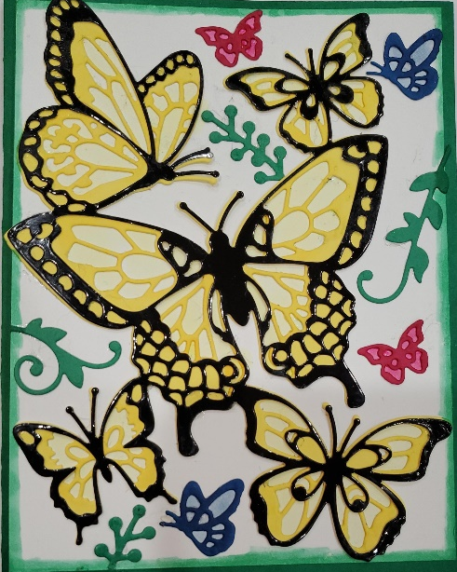
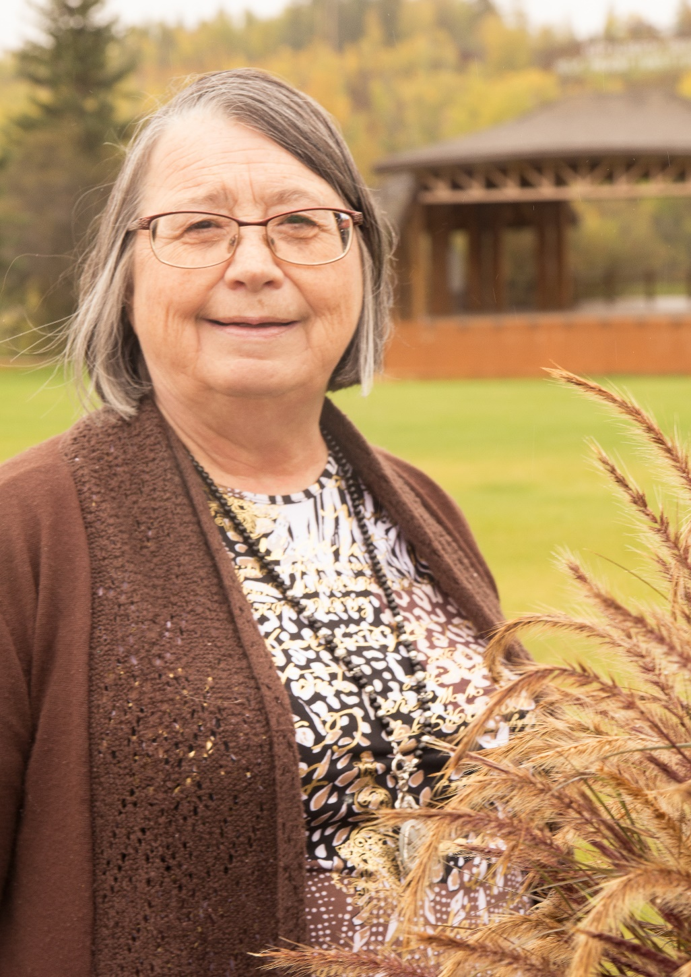
Tech Support: Tim McKenna, Tim Rosborough, Robert Belland
January 23, 1954-January 3, 2021

